|  |  |
| --- | --- |
| DATE | 06/11/2022 |
| TEAM ID | PNT2022TMID50655 |
| PROJECT NAME | Industry-specific intelligent fire management  system |

**Develop A Web Application Using Node-RED**

**Steps Followed**:

● **Opened a Node-RED project**

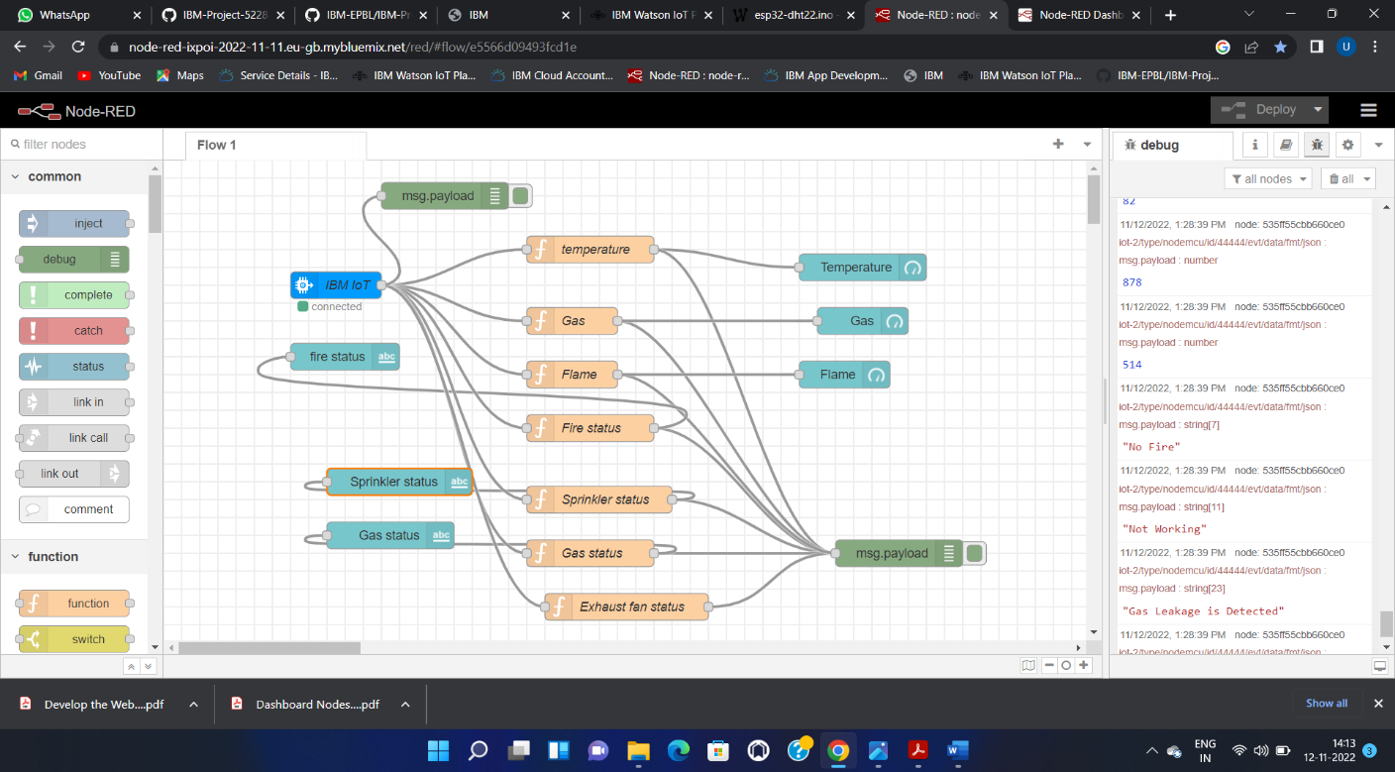

● **Added code to get Temperature in python**

#include <time.h>

#include <WiFi.h>

#include <PubSubClient.h>

#define ORG "7iw80s"

#define DEVICE_TYPE "nodemcu"

#define DEVICE_ID "44444"

#define TOKEN "12345678"

char server[] = ORG ".messaging.internetofthings.ibmcloud.com";

char publishTopic[] = "iot-2/evt/data/fmt/json";

char authMethod[] = "use-token-auth";

char token[] = TOKEN;

char clientId[] = "d:" ORG ":" DEVICE_TYPE ":" DEVICE_ID;

WiFiClient wifiClient;

PubSubClient client(server, 1883, wifiClient);

float temperature  = 0;

int gas = 0;

int flame = 0;

String flame_status = "";

String Gas_status = "";

String exhaust_fan_status = "";

String sprinkler_status = "";

void setup() {

**Serial**.begin(99900);

   wifiConnect();

   mqttConnect();

}

